Name SURNAME1, Name SURNAME2

1 Affiliation according to the following formula

2 University of Bielsko-Biala, Department of Civil Engineering, Willowa 2, 43-309 Bielsko-Biała, Poland

ORCID / e-mail: must be completed for at least one person

1 0000-xxxx-xxxx-xxxx / xxxxxxxx@xxxxxx

2 0000-xxxx-xxxx-xxxx / xxxxxxx@xxxxxxx

**Title**

**Keywords:**

3-5 words

**Title in Polish**

**Słowa kluczowe:**

3-5 words in Polish

**Abstract**

10-12 lines

**Abstrakt**

10-12 lines in Polish

**1. Introduction**

The article must be written in Arial 11 pt. regular font with single line spacing. The font size for text in tables can be reduced. Main chapters must be numbered. **It is necessary to present the purpose of the paper (preferably in the introduction).**

Literature in the text must be cited in square brackets. In the case there is only one author, the name and year [Kowalski 2000] are placed. In the case of two authors, the conjunction “and” must be included [Kowalski and Nowak 2000]. In the case of three or more authors, the first author is provided, adding “et al.” [Kowalski et al. 2000]. If there is no author, the title of the material is entered [ISO 14688-2:2004] [Website 1], which will begin the bibliographic note in the literature list.

Refer to tables in the text (Table 1), numbering them sequentially regardless of the chapter numbering. Do the same with figures (Fig. 1), which include photographs. Borrowed tables, graphics, photographs cannot be used and published without written permissions by their authors. Below is an example of chapter layout - the author creates the layout of the article according to his own concept.

**2. RESEARCH METHODS**

Main chapters (level 1 sections) must be numbered.

**3. Results and discussion**

**3.1. Level 2 section**

Level 2 sections must be numbered.

***Level 3 section***

Level 3 sections must not be numbered.

**Tab. 1.** Title of the table

|  |  |  |  |
| --- | --- | --- | --- |
| Column title | Column title | Column title | Column title |
| Row title |  |  |  |
| Row title |  |  |  |
| Row title |  |  |  |

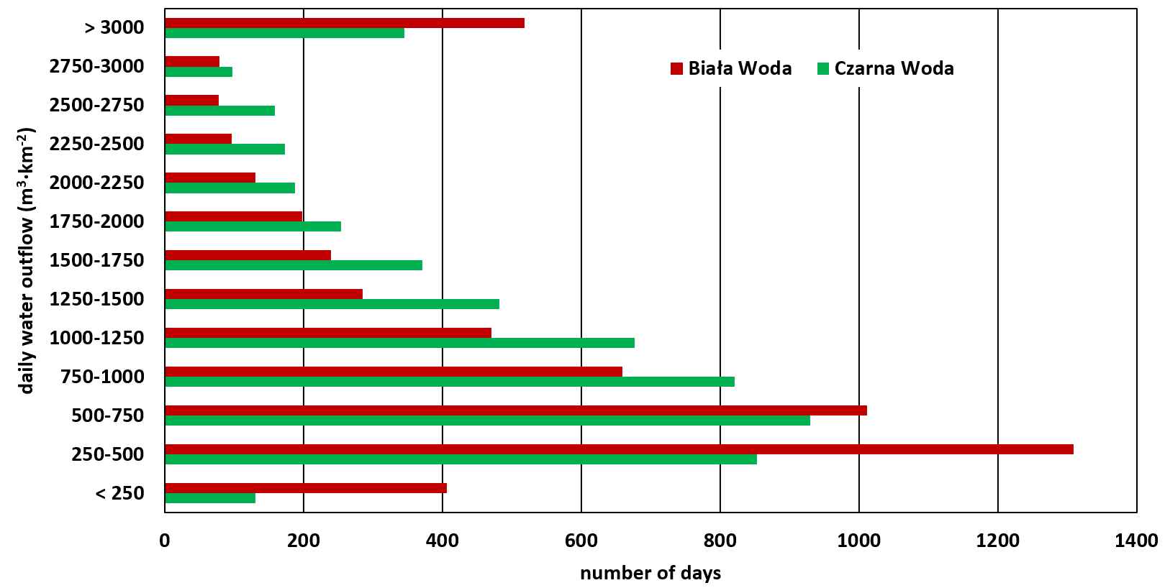

**Fig. 1.** Figure caption

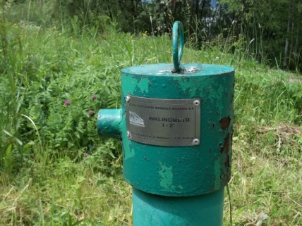

**Fig. 2.** Figure caption (photo by A. Jaguś).

**4. CONCLUSIONS or SUMMARY or FINAL REMARKS**

1. If conclusions are chosen, they must be bulleted.
2. Conclusion must be bulleted.
3. Conclusion must be bulleted.
4. Conclusion must be bulleted.

**Acknowledgements (optionally)**

*Information from the author.*

**REFERENCES**

The list of used materials must follow alphabetical order without numbering, in accordance with the following examples:

ASTM D 2974-87 (1987). Standard Test Methods for Moisture, Ash, and Organic Matter of Peat and Other Organic Soils. ASTM, West Conshohocken.

Carpenter S.R., Kitchell J.F., Hodgson J.R. 1985. Cascading trophic interactions and lake productivity. *BioScience*, 35, 634–639.

Germaine J.T., Germaine A.V. 2009. Geotechnical laboratory measurements for engineers. 1st ed. John Wiley & Sons, Hoboken.

Huang P.T., Patel M., Santagata M.C., Bobet A. 2009. Classification of Organic Soil. Final Report. FHWA/IN/JTRP-2008/2. Joint Transportation Research Program, Indiana Department of Transportation and Purdue University, West Lafayette.

ISO 14688-2:2004. Geotechnical investigation and testing – Identification and classification of soil – Part 2: Principles for a classification. **International Organization for Standardization, Geneva.**

Lincheva S., Todorova Y., Topalova Y. 2014. Long-term assessment of the self-purification potential of a technologically managed ecosystem: the Middle Iskar cascade. *Biotechnology & Biotechnological Equipment*, 28, 3, 455–462.

Martyniuk E., Rzepecki R. 1995. Sheep husbandry in Poland – an outline. [In:] Strategies for sheep and goat breeding (Ed. D. Gabina). CIHEAM, Zaragoza, 121–131.

Website 1: https://byjus.com/physics/photon/ (available in January 2025).